1. **[OPTIONAL]** Read chapter #5 ‘Control Statements - Java Selection Statements - if’ of ‘Java: The Complete Reference - Herbert Schildt’  
   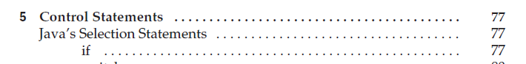
2. Implement console program which will meet the following requirements:
   1. Program can be started in ‘admin’ and ‘guest’ mode
   2. To start program in ‘admin’ mode any of multiple string arguments should be equal to ‘--admin’
   3. To start program in ‘guest’ mode any of multiple string arguments should be equal to ‘--guest’
   4. Program cannot be started with ‘--admin’ and ‘--guest’ arguments simultaneously
   5. If program is started in ‘admin’ mode then "Hello, Admin!" is printed to console
   6. If program is started in ‘guest’ mode then "Hello, Guest!" is printed to console
   7. If program is started with ‘--admin’ and ‘--guest’ arguments then program prints "Please, select either 'ADMIN' or 'GUEST' mode for this program" to console
3. Implement console program which will meet the following requirements:
   1. Program is started with two arguments (numbers)
   2. Program adds these two numbers
   3. In case one of the input arguments is floating-point number - the result of addition is floating-point number
   4. In case two arguments are integer - the result of addition is integer